Cointegration and ECM: USDCHF and USDCAD
Method 27 / Engle-Granger on log closes / one-lag ECM / Alpari D1 full available history

Study setup
Logical pair: PX=USDCHF , PY=USDCAD
Broker symbols: USDCHF_i , USDCAD_i
Snapshot: 2026-11-03_majors_alpari_D1
Timeframe: D1
Matched window: 1999-01-05 to 2026-11-02 (UTC bar dates)
Matched level count n: 7188
Dropped unfinished last bar dated 2026-11-03 UTC after a tick-volume check against the prior complete day.
ECM lags of deltas: 1
Complete matched rows (Excel): USDCHF-USDCAD_Coint_D1.xlsx
Complete matched rows (HTML table): USDCHF-USDCAD_Coint_D1_data.html

Method carried forward
Engle-Granger cointegration works on log price levels, not returns. For each unordered pair, PX is the left leg and PY the right leg. Step one: OLS ln(PY) = alpha + beta * ln(PX) + e. Step two: statsmodels Engle-Granger coint test on (ln(PY), ln(PX)). Error-correction: delta ln(PY)_t = c + kappa * e_{t-1} + lagged delta ln(PY) and delta ln(PX) (one lag each) + u_t. Headline is the Engle-Granger p-value (lower = stronger evidence of a stationary spread) with kappa and beta reported alongside. Same-sample Pearson r of log returns is a side check only. beta is not an automatic lot-size hedge. This is not a trading signal.

Results (headline)
alpha: 0.208485
beta: 0.270618
Engle-Granger t: -1.129822
Engle-Granger p: 0.875333
5% critical value: -3.336980
ECM kappa: -0.000540
kappa t-stat: -1.1051
ECM R^2: 0.003042
spread std: 0.123982
Pearson r (returns): 0.304665

Conclusion
Engle-Granger for PY=USDCAD on PX=USDCHF: beta=0.2706, alpha=0.2085, coint_t=-1.1298, p=0.8753 (5% crit=-3.3370). ECM kappa=-0.0005 (t=-1.11). Pearson r of returns = 0.3047. beta is not a lot-size hedge. Not a trading signal.

Charts
Daily closes

Engle-Granger residual spread
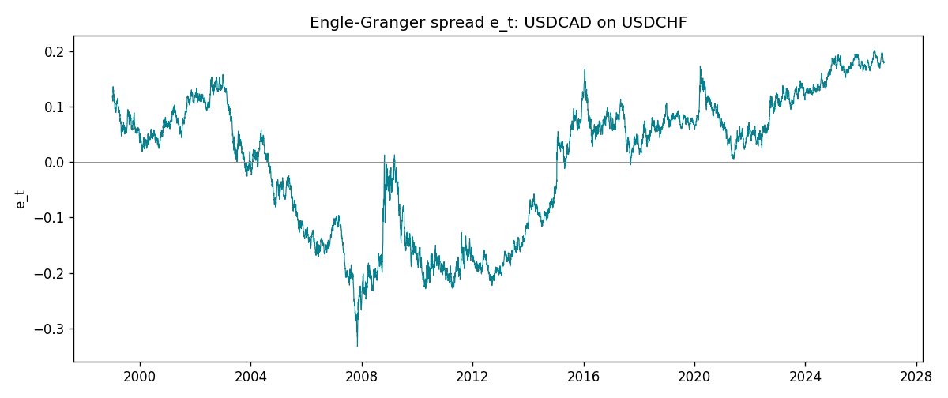
Daily log returns
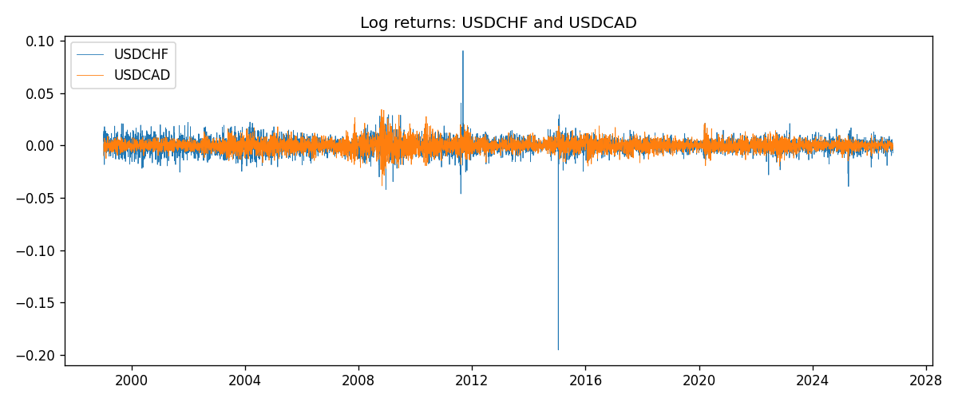

Data report
Matched rows are in the sibling Excel workbook named USDCHF-USDCAD_Coint_D1.xlsx. Embedding all rows as a Word table is impractical; this file holds column summaries and the first and last 15 matched rows.
Column summaries
column | count | mean | std | min | 25% | 50% | 75% | max
USDCHF_open | 7188 | 1.0975966 | 0.25229688 | 0.72022 | 0.9205375 | 0.989955 | 1.2378 | 1.8219
USDCAD_open | 7188 | 1.2667824 | 0.16892678 | 0.9168 | 1.1183975 | 1.298465 | 1.3720475 | 1.6183
USDCHF_high | 7188 | 1.1028875 | 0.2540352 | 0.73305 | 0.924845 | 0.993545 | 1.242375 | 1.8313
USDCAD_high | 7188 | 1.2716804 | 0.16888565 | 0.9336 | 1.12285 | 1.30387 | 1.37646 | 1.619
USDCHF_low | 7188 | 1.0924772 | 0.25071604 | 0.08565 | 0.91725 | 0.9863 | 1.23155 | 1.8121
USDCAD_low | 7188 | 1.2622243 | 0.16896256 | 0.9056 | 1.114065 | 1.293535 | 1.3677775 | 1.6102
USDCHF_close | 7188 | 1.0975873 | 0.25219296 | 0.72025 | 0.920805 | 0.98995 | 1.2379 | 1.8217
USDCAD_close | 7188 | 1.2667976 | 0.16890032 | 0.916 | 1.118075 | 1.29844 | 1.372365 | 1.6137
USDCHF_tick_volume | 7188 | 74305.244 | 113479.97 | 1 | 12787.25 | 40220 | 70419.75 | 858589
USDCAD_tick_volume | 7188 | 81017.898 | 147302.44 | 1 | 5560 | 40941.5 | 71627 | 1410818
USDCHF_spread | 7188 | 26.050501 | 24.7086 | 0 | 5 | 16 | 50 | 100
USDCAD_spread | 7188 | 23.4399 | 18.261108 | 0 | 9 | 17 | 40 | 60
USDCHF_real_volume | 7188 | 2.3284369e+10 | 8.9116261e+10 | 0 | 0 | 0 | 0 | 1.9331921e+12
USDCAD_real_volume | 7188 | 1.8376704e+10 | 9.6688094e+10 | 0 | 0 | 0 | 0 | 2.5751613e+12
USDCHF_log_price | 7188 | 0.06966016 | 0.21062575 | -0.32815691 | -0.08250699 | -0.01010084 | 0.2134164 | 0.59977013
USDCAD_log_price | 7188 | 0.22733626 | 0.13645668 | -0.08773891 | 0.11160846 | 0.26116354 | 0.31653553 | 0.47852968
USDCHF_log_return | 7188 | -7.133e-05 | 0.00659527 | -0.19545699 | -0.0033544 | 8.077e-05 | 0.00332477 | 0.09051364
USDCAD_log_return | 7188 | -1.556e-05 | 0.00514382 | -0.03859748 | -0.00283746 | 4.44e-05 | 0.00272629 | 0.03436319
spread_e | 7188 | 0 | 0.12398197 | -0.33251205 | -0.12084186 | 0.04342194 | 0.09311449 | 0.20166033
ecm_fitted | 7187 | -1.415e-05 | 0.00028363 | -0.00294842 | -0.00017906 | -2.5e-05 | 0.00013845 | 0.00648257
First 15 matched rows (selected columns)
time | USDCHF_log_price | USDCAD_log_price | spread_e | USDCHF_log_return | USDCAD_log_return
1999-01-05 | 0.31656103 | 0.41363167 | 0.11947962 | 0.0039424743 | -0.010131666
1999-01-06 | 0.33016668 | 0.41330099 | 0.11546701 | 0.013605652 | -0.0003306769
1999-01-07 | 0.3207783 | 0.4148212 | 0.11952789 | -0.0093883841 | 0.0015202092
1999-01-08 | 0.33181857 | 0.41277168 | 0.11449067 | 0.011040268 | -0.0020495197
1999-01-11 | 0.33711489 | 0.40925791 | 0.10954362 | 0.0052963193 | -0.0035137769
1999-01-12 | 0.32728733 | 0.41587738 | 0.1188226 | -0.0098275602 | 0.0066194721
1999-01-13 | 0.30902763 | 0.4204194 | 0.12830603 | -0.018259701 | 0.0045420214
1999-01-14 | 0.30660196 | 0.42735705 | 0.13590011 | -0.0024256692 | 0.0069376546
1999-01-15 | 0.32454424 | 0.42166649 | 0.12535404 | 0.01794228 | -0.0056905671
1999-01-18 | 0.3213586 | 0.42264993 | 0.12719958 | -0.0031856384 | 0.00098344542
1999-01-19 | 0.32128608 | 0.42539845 | 0.12996771 | -7.2518946e-05 | 0.002748513
1999-01-20 | 0.32851207 | 0.41943376 | 0.12204755 | 0.0072259871 | -0.0059646885
1999-01-21 | 0.3246888 | 0.41515138 | 0.11879981 | -0.0038232689 | -0.0042823796
1999-01-22 | 0.32454424 | 0.41765715 | 0.1213447 | -0.0001445609 | 0.0025057712
1999-01-25 | 0.32699893 | 0.41851295 | 0.12153622 | 0.0024546976 | 0.00085579808
Last 15 matched rows (selected columns)
time | USDCHF_log_price | USDCAD_log_price | spread_e | USDCHF_log_return | USDCAD_log_return
2026-10-13 | -0.18339413 | 0.3516423 | 0.19278705 | -0.0024955621 | -0.0046395653
2026-10-14 | -0.1804553 | 0.35316078 | 0.19351022 | 0.0029388325 | 0.0015184751
2026-10-15 | -0.19024083 | 0.34955063 | 0.19254821 | -0.0097855323 | -0.0036101503
2026-10-16 | -0.19386391 | 0.34611842 | 0.19009648 | -0.0036230826 | -0.0034322068
2026-10-19 | -0.19022874 | 0.34423489 | 0.1872292 | 0.0036351779 | -0.0018835331
2026-10-20 | -0.19285686 | 0.34052829 | 0.18423382 | -0.0026281224 | -0.0037066008
2026-10-21 | -0.19325713 | 0.33968137 | 0.18349522 | -0.00040027413 | -0.00084691787
2026-10-22 | -0.19806077 | 0.33705064 | 0.18216444 | -0.0048036381 | -0.0026307268
2026-10-23 | -0.19240826 | 0.3370792 | 0.18066333 | 0.005652514 | 2.85545e-05
2026-10-26 | -0.19056746 | 0.3371363 | 0.18022228 | 0.0018407959 | 5.7106554e-05
2026-10-27 | -0.18795741 | 0.33967425 | 0.1820539 | 0.0026100526 | 0.0025379458
2026-10-28 | -0.18897162 | 0.33583632 | 0.17849044 | -0.0010142111 | -0.0038379274
2026-10-29 | -0.19383964 | 0.33572196 | 0.17969344 | -0.0048680164 | -0.00011436495
2026-10-30 | -0.19312369 | 0.33469208 | 0.17846982 | 0.00071594559 | -0.0010298736
2026-11-02 | -0.20026966 | 0.33530727 | 0.18101884 | -0.0071459744 | 0.00061519094

